**Homework #2 – 3D Travel**

**UNITY SCENE – VIRTUAL ENVIRONMENT**

Our 3D Virtual Environment presents an interior of a kid’s room where you can find a total of 13 objects. There is a designer wall, three plain white walls, a ceiling, a carpet, a chandelier, a door, a plant, some furniture and toys. Furniture includes a crib, a closet and a bookshelf. Among toys, you can find: an airplane, a car, a train and a cartoon art piece.

**TRAVEL TECHNIQUE - INTERACTION STATES**

We have developed following five interaction techniques –

* **Steering Forward** – The user steers in forward direction.
* **Steering Backward** – The user steers in backward direction.
* **Steering Leftward** – The user strafes (moving side by side) in left direction.
* **Steering Rightward** – The user strafes (moving side by side) in right direction.
* **No Steering** – This is the idle state. The use is in this state, when the user is not in any of the above defined states and the joystick is in the center position.

State diagram –

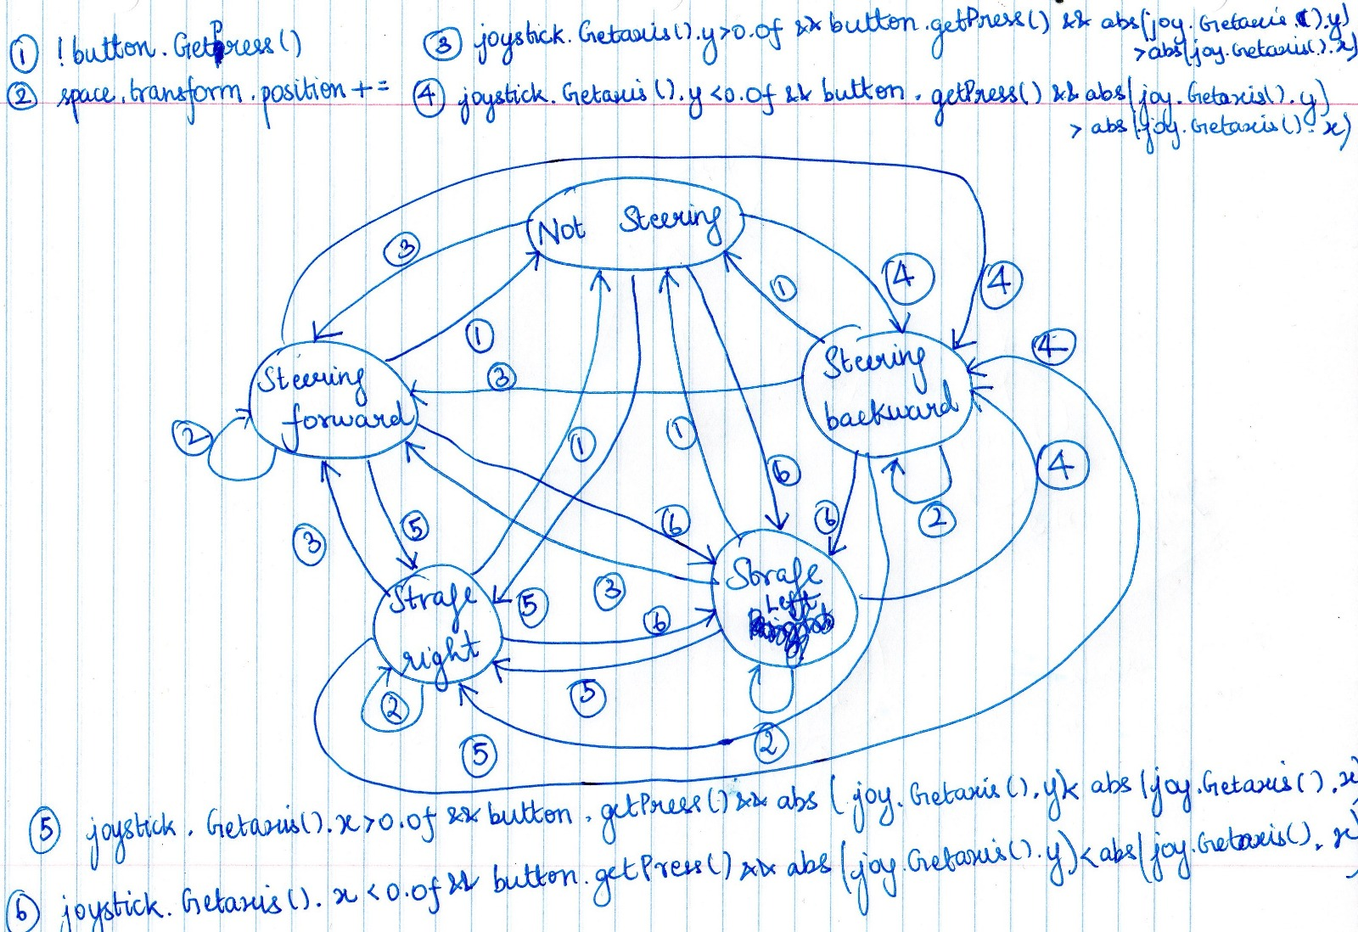

**3D SOUNDS**

Our virtual environment contains following five realistic sounds –

* **Musical box (World>bookshelf>Normal Bookcase>Musical Box)** – the musical box, lying on the top shelf of left bookshelf, produces a lullaby.
* **Toy train (World>Locomotive) –** the toy train, lying on the floor, produces real sound of train whistling.
* **Banging on the door (World>Barcelona_o) –** the main door, in the wall opposite to main wall, produces the sound as if someone is banging fervently on it from outside.
* **Cartoon joker toy (World>Cartoon_Boy) –** the joker art piece, lying on the floor, produces a pixie voice saying, “This is enchanted”.
* **Swinging Chandelier (World>lustra) –** the chandelier, hanging from the ceiling, swings with the air.